
FURTHER EDUCATION AND TRAINING CERTIFICATE: INFORMATION TECHNOLOGY: SYSTEMS DEVELOPMENT
ID 78965 LEVEL 4 – CREDITS 165
LEARNER WORKBOOK
SAQA: 9016
REPRESENT ANALYSE AND CALCULATE SHAPE AND MOTION IN 2-AND 3-DIMENSIONAL SPACE IN DIFFERENT CONTEXTS

Learner Information:
Details | Please Complete this Section
Name & Surname:
Organisation:
Unit/Dept:
Facilitator Name:
Date Started:
Date of Completion:

Copyright
All rights reserved. The copyright of this document, its previous editions and any annexures thereto, is protected and expressly reserved. No part of this document may be reproduced, stored in a retrievable system, or transmitted, in any form or by any means, electronic, mechanical, photocopying, recording or otherwise without the prior permission.

OVERVIEW
About the Learner Workbook | This Learner Exercise Workbook has been designed and developed to evaluate learners’ level of understanding of the FURTHER EDUCATION AND TRAINING CERTIFICATE: INFORMATION TECHNOLOGY: TECHNICAL SUPPORT  ID 78964 LEVEL 4 – 163 CREDITS  It forms part of a series of Learner Workbooks that have been developed for
Purpose | The purpose of this Learner Exercise Workbook is to evaluate learners understanding on the specific outcomes and/or assessment criteria of the following SAQA Registered Unit Standards:
US No | US Title | Level | Credits
9016 | Represent analyse and calculate shape and motion in 2-and 3-dimensional space in different contexts | 4 | 4
Context | This assessment represents the Formative Assessment component of the Represent analyse and calculate shape and motion in 2-and 3-dimensional space in different contextsfor the and should be completed in the classroom/training room.
Resources | The following are resources needed for this assessment:  - Learner Guide; and  - Assessment Preparation.
Instructions to Facilitators | Facilitators will be required to:  - Explain the completion of the workbook to each learner; and  - Interview the learner on similar questions, should he/she not be able to write.
Instructions to Learners | Learners will be required to:  - Complete the workbook as per the instructions;  - Ensure that all questions are completed;  - Ensure that the completion of the workbook is their own work;  - Ensure that all annexure are attached to the workbook and clearly referred to;
Assessment Time | Learners are required to complete this assessment within the allocated time frame of.... hours.
Total Mark | This formative assessment carries a total mark of _ points. In order to meet the pass mark, learners are required to achieve a minimum of 80% of the total marks.
Equipment | Learners are required to have the following equipment in order to complete this workbook:  - Pen and Pencil;  - Ruler; and  - Exam Pad – for additional paper.

GENERAL INFORMATION

LEARNER DETAILS
Learner Full Names
Learner ID No.:
Organisation:
Unit/Dept:
Contact Details: | Telephone /Cell Numbers: | Email Address:
WORKSHOP DETAILS
Workshop Venue:
Facilitator Name:
Date Started:
Date Completed:

ASSESSMENT PREPARATION CHECKLIST

DESCRIPTION |  |  | YES | NO | COMMENTS/CONTINGENCY
This assessment is a formative assessment and it is based on the outlined unit standard/s for the Represent analyse and calculate shape and motion in 2-and 3-dimensional space in different contextsmodule.
Your assessment evidence for Represent analyse and calculate shape and motion in 2-and 3-dimensional space in different contextsmodule needs to be submitted on....... (day) of...............(month)...........(year) at the following address/place................................................................
You will be assessed based on the outlined Unit Standards. The assessment activities are linked to specific outcomes/assessment criteria of the outlined Unit Standards.
To determine your competence level, the following are the methods to be used for this assessment:
- .....................................................
- .....................................................
To be declared competent on Represent analyse and calculate shape and motion in 2-and 3-dimensional space in different contextsmodule (formative assessment), you should have obtained at least 80% of the total mark of this assessment.
You will be provided with detailed feedback on your performance of this assessment as follows:
- Written Feedback
- Verbal Feedback
Should you be declared “not yet competent” on this assessment, you will be entitled for re-assessment opportunity/ies.
You will be required to re-submit evidence (only for areas) you were declared not yet competent. A date for re-submission will be agreed with the assessor.
You will be entitled to lodge an appeal should you not be satisfied with the assessment decision of your assessment.
You will be required to provide the assessor feedback on assessment procedure – this is to assist in improving the assessment practices.
Your results of assessment and portfolio of evidence information will not be provided to any person without your written consent.
Learner’s Declaration
I…………………………………………………………………………………………….herewith declare that I am ready for the assessment, that we have reviewed the assessment preparation and plan, I understand the assessment process and I am happy that the assessment will be conducted in a fair manner.
Learner Signature: | Date: | Facilitator Signature: |  |  |  | Date:

Represent analyse and calculate shape and motion in 2-and 3-dimensional space in different contexts
Learning Unit1
UNIT STANDARD NUMBER : 9016
LEVEL ON THE NQF : 4
CREDITS : 4
FIELD : Physical, Mathematical, Computer and Life Sciences
SUB FIELD : Mathematical Sciences
PURPOSE: | This unit standard is designed to provide credits towards the mathematical literacy requirements of the NQF at level 4. The essential purposes of the mathematical literacy requirements are that, as the learner progresses with confidence through the levels, the learner will grow in:  - An insightful use of mathematics in the management of the needs of everyday living to become a self-managing person.  - An understanding of mathematical applications that provides insight into the learner`s present and future occupational experiences and so develop into a contributing worker.  - The ability to voice a critical sensitivity to the role of mathematics in a democratic society and so become a participating citizen.  People credited with this unit standard are able to:  - Measure, estimate, and calculate physical quantities in practical situations relevant to the adult with increasing responsibilities in life or the workplace  - Explore analyse and critique, describe and represent, interpret and justify geometrical relationships and conjectures to solve problems in two and three dimensional geometrical situations
LEARNING ASSUMED TO BE IN PLACE:
The credit value is based on the assumption that people starting to learn towards this unit standard are competent in Mathematical Literacy and Communications at NQF level 3.
  Activities | Complete the following questions as per instructions provided

1. Polygons
The perimeterof a polygon is the distance around the “rim” or edge of the figure. Linear units such as inches, feet, meters or miles are used to measure perimeter. To find the perimeter of a polygon, add the lengths of all its sides.

1.1 Calculate the perimeter of a room that is 23 metres long and 15 metres wide. Show your calculations:
___________________________________________________________________________________________________________________________________________________________________________________________________________________________________________________________________________________________________________________________________________________________________________________________________________________________________________________________________________________________________________________________________________________________________________________________________________________
1.2 A rectangular swimming pool is 11, 5 m long and 5 m wide. How many metres of fencing are needed to enclose the pool if you erect the fencing 2m from the edge? Show your calculations:
___________________________________________________________________________________________________________________________________________________________________________________________________________________________________________________________________________________________________________________________________________________________________________________________________________________________________________________________________________________________________________________________________________________________________________________________________________________
1.3 In the following floor plan of a house, find the perimeter of each room and the perimeter of the entire building (Leave out the porch, bay window and optional storage):
Master bedroom
Master bathroom
Foyer
Dining room
Side entrance at kitchen
Breakfast nook and kitchen
Family room
Entire house

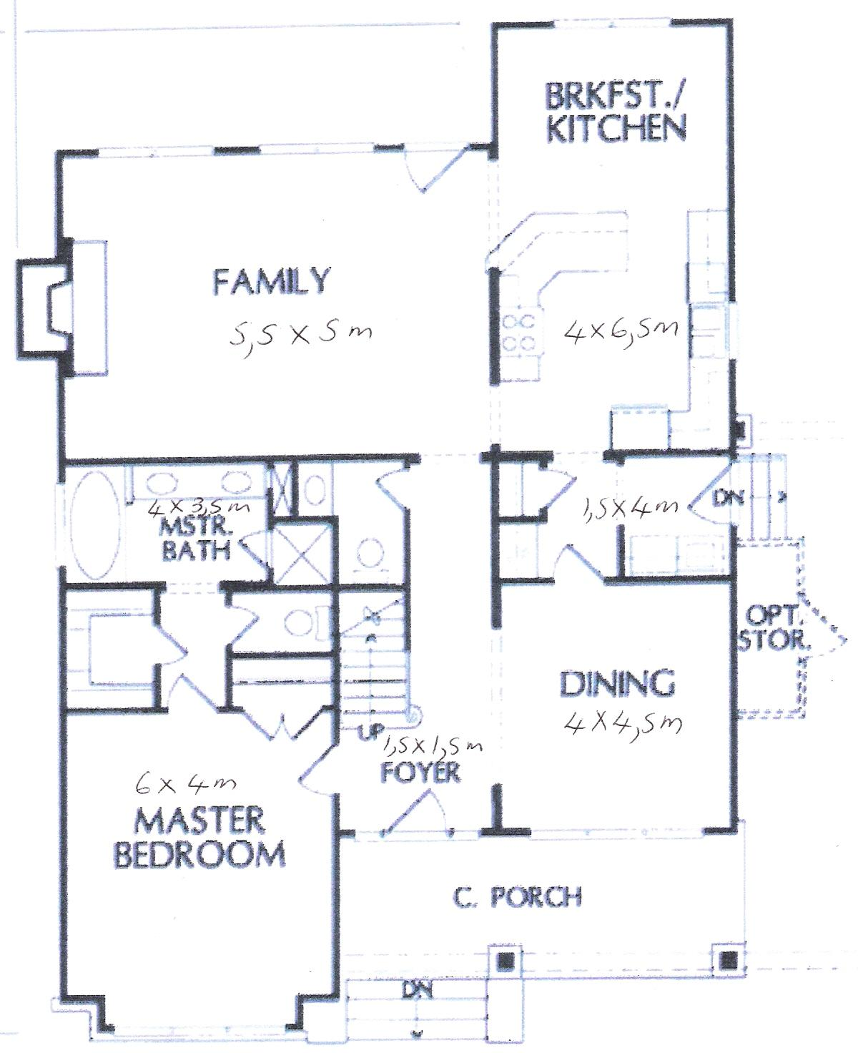

1.4 Calculate the area of each of the rooms in the house:
Master bedroom
Master bathroom
Foyer

Dining room

Side entrance at kitchen

Breakfast nook and kitchen

Family room

1.5 At R48.50 a square metre, what is the cost of laying a cement floor in a garage that is 6m long and 4 m wide?
_________________________________________________________________________________________________________________________________________________________________________________________________________________________________________________________________________________________________________________________________________________________________________________________________________________________________________________________________________________________________________________________________________________________________________________________________________________________________________________________________________________________________________________________________________________________________________________________________________________________________________________________________________________________________________________________________________________________________________________________________________________________________________________________________________________________________________________________________________________
  - Write down the formulae for calculating volume for each of the shapes shown in your Learner Guide on page 5:
Shape | Formula
Cylinder

Rectangular solid

Cube

Pyramid

  - The rectangular swimming pool referred to in 1.2 is 11,5 m long, 5 m wide and 3m deep throughout. Calculate its volume.
________________________________________________________________________________________________________________________________________________________________________________________________________________________________________________________________________________________________________________________________________________________________________________________________________________________________________________________________________________________________________________________________________________________________________________________________________________________________________________________________________________________________________

- Calculate the area of a triangle whose base is 13.9 m. and whose altitude is 7.8 m:
______________________________________________________________________________________________________________________________________________________________________________________________________________________________________________________________________________________________________________________________________________________________________________________________________________________________________________________________________________________________________________________________

3. Calculate the area of parallelogram GDEF if the base is 5m and the altitude is 3,2m
F
E

3,2m

5m
G
D

_____________________________________________________________________________________________________________________________________________________________________________________________________________________________________________________________________________________________________________________________________________________________________________________________________________________________________________________________________________________________________________________________________________________________________________________________________________________________________________________________________________________________________________________________________________________________________________________________
4. Calculate the area of a parallelogram whose base is 17,9 cm and whose altitude is 30,25 cm in length.
___________________________________________________________________________________________________________________________________________________________________________________________________________________________________________________________________________________________________________________________________________________________________________________________________________________________________________________________________________________________________________________________________________________________________________________________________________________

5. Find the area of a rectangle whose base is 8.4 m and whose altitude is 15.6 m in length. Show your calculation:
______________________________________________________________________________________________________________________________________________________________________________________________________________________________________________________________________________________________________________________________________________________________________________________________________________________________________________________________________________________________________________________________

6. How many cubes were needed to build the design in this figure?
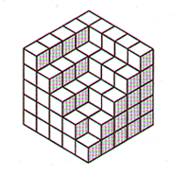

_______________________________________________________________________________________________________________________________________________________________________________________________________________________________________________________________7. Find the circumference and area of a circle whose diameter is 14 cm:
C =

A =

8. Can a circular table top with diameter 2.7 metres long fit through a doorway 2.5 metres high and 1 metre wide? Why or why not?
Yes/ No

Reason:

9. How far up on a wall of a building will a 10-meter ladder reach if the foot of the ladder is 1,25 metres from the wall? Draw the situation and then explain your answer.
________________________________________________________________________________________________________________________________________________________________________________________________________________________________________________________________________________________________________________________________________________________________________________________________________________________________________________________________________________________________________________________________________________________________________________________________________________________________________________________________________________________________________

10. What is the length of the longest pole you could put in a rectangular storage room 12 units long, 9 units wide, and 8 units high? Explain.
________________________________________________________________________________________________________________________________________________________________________________________________________________________________________________________________________________________________________________________________________________________________________________________________________________________________________________________________________________________________________________________________________________________________________________________________________________________________________________________________________________________________________
11. Calculate the sum of the measures of the interior angles of the following polygons. Name the shape and then do your calculations next to the relevant shape:


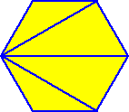

12. Measure surface area:

12.1
Draw a picture of your file in the space provided. Measure your file and write its dimensions down on the drawing. Calculate what size paper you would need to cover it. Leave 2cm on each side for the overlap.
________________________________________________________________________________________________________________________________________________________________________________________________________________________________________________________________________________________________________________________________________________________________________________________________________________________________________________________________________________________________________________________________________________________________________________________________________________________________________________________________________________________________________________________________________________________________________________________________________________________________________________________________________________________________________________________________________________________________________________________________________________________________________________________________________________________________________________________________________________________________________________________________________________________________________________________________________________________________________________________________________________________________________________________________________________

12.2 The training room

A. If you wanted to carpet the training room, what size carpet would you need to buy?
___________________________________________________________________________________________________________________________________________________________________________________________________________________________________________________________________________________________________________________________________________________________________________________________________________________________________________________________________________________________________________________________________________________________________________________________________________________
B. If you wanted to tile the training room walls, and each box of tiles= 1,2m², how many boxes would you require?
__________________________________________________________________________________________________________________________________________________________________________________________________________________________________________________________________________________________________________________________________________________________________________________________________________________________________________________________________________________________________________________________________________________________________________________________________________________________________________________________________________________________________________________________________________________________________________________________________________________________________________________________________________________
C. At a cost of R55 per box, how much would it cost to tile the training room?
___________________________________________________________________________________________________________________________________________________________________________________________________________________________________________________________________________________________________________________________________________________________________________________________________________________________________________________________________________________________________________________________________________________________________________________________________________________

13. You want to share the following recipe with your friends in Australia and Britain. Convert the recipe to their relevant units:

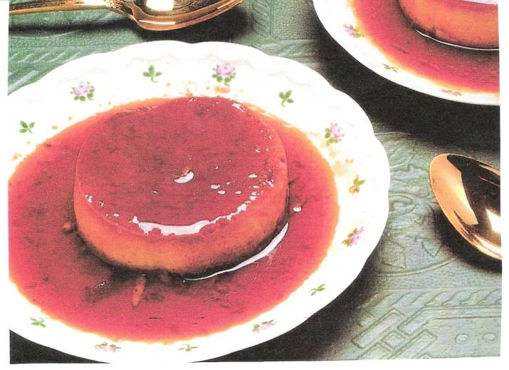
Classic Crème Caramel

940 ml milk
375 ml vanilla sugar
5 eggs
4 egg yolks
15 ml vanilla

Scald the milk and allow to cool 20 minutes. In a saucepan, melt 180 ml of sugar and cook until dark brown, stirring constantly. Take care not to scorch. Pour into a warm mould, covering the bottom and sides. Beat the eggs and egg yolks with the remaining sugar. Slowly whip in the milk and vanilla. Pour into the sugar-lined mould.
Place mould in a second pan filled halfway with hot water. Bake for 45 minutes in a 160° oven. Cool, then chill. To serve, invert on to a rimmed serving platter.

SERVES 6

 | Britain (Imperial) | Australia
Milk (940 ml)
Vanilla sugar (375 ml)
Vanilla (15 ml)
Oven (160°)

14. Speed and distance

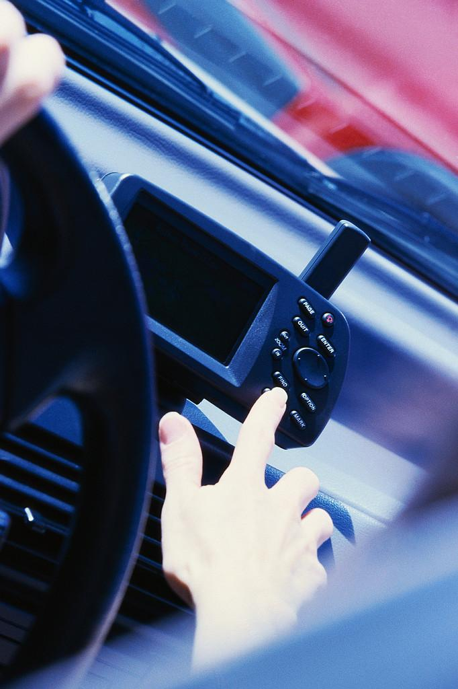

Read the 2004 Audi A6 specifications (you will recognise them from unit standard 119457) and then answer the questions that follow:
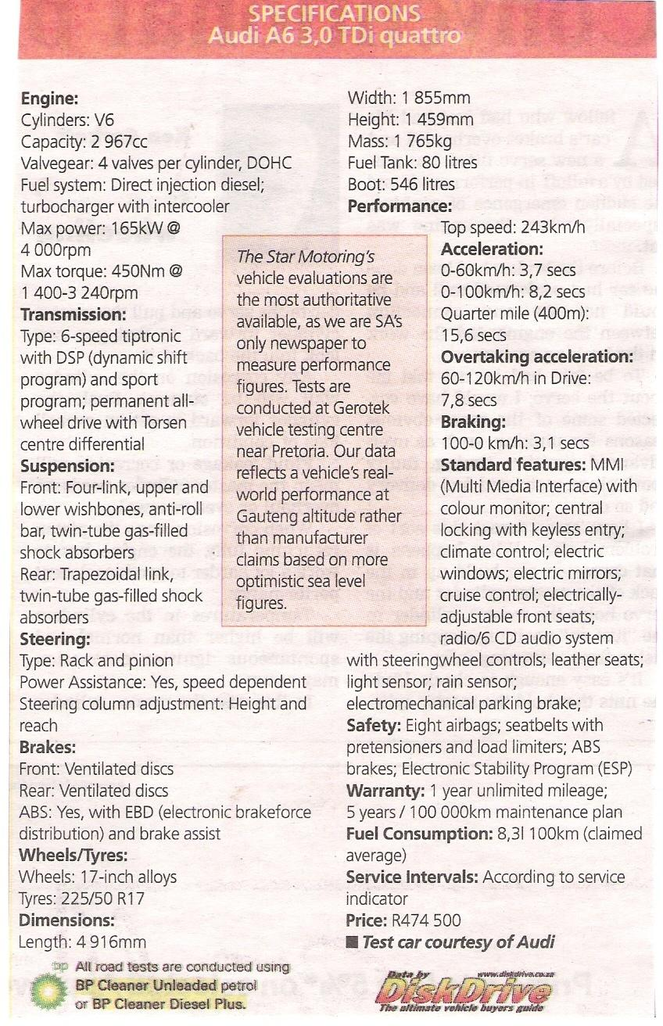
14.1 Find three examples of specifications regarding volume:
__________________________________________________________________________________________________________________________________________________________________________________________________________________________________________________________________________________________________________________________________________________________________________________________________________________________________________________________________________________________________________________________________________________________________________________________________________________________________________________________________________________________________________________________________________________________________________________________________________________________________________________________________________________

14.2 If the diameter of the Audi’s wheels is 17 inches, calculate the circumference of the wheel.
___________________________________________________________________________________________________________________________________________________________________________________________________________________________________________________________________________________________________________________________________________________________________________________________________________________________________________________________________________________________________________________________________________________________________________________________________________________

14.3 If you travel to Durban from Johannesburg (650 km) in your new Audi A6, how much petrol will you use on average?
___________________________________________________________________________________________________________________________________________________________________________________________________________________________________________________________________________________________________________________________________________________________________________________________________________________________________________________________________________________________________________________________________________________________________________________________________________________
14.4 How long will it take you to get to Durban from Johannesburg at an average speed of 120 km/h?
___________________________________________________________________________________________________________________________________________________________________________________________________________________________________________________________________________________________________________________________________________________________________________________________________________________________________________________________________________________________________________________________________________________________________________________________________________________

14.5 Give the dimensions of the Audi A6 in metres:
___________________________________________________________________________________________________________________________________________________________________________________________________________________________________________________________________________________________________________________________________________________________________________________________________________________________________________________________________________________________________________________________________________________________________________________________________________________

15. The following chart reflects the profits (in millions) made by three shafts of a platinum mine over a period of a year.
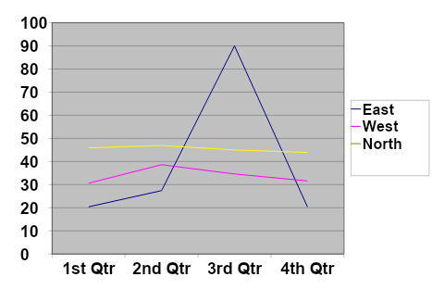Compare the performance of the three shafts by reading the figures at the end of each quarter off the chart. Tabulate the figures. Write in the names of the shafts on the left. (The answers will be approximations)
Shaft | 1st | 2nd | 3rd | 4th

SELF-ASSESSMENT

The learner must make use of the following self-evaluation checklist to rate himself against the learning outcomes of this particular training module in establishing the level of mastery of the information.
1. Not able to comply
2. Reasonable compliance (Not acceptable for final evaluation)
3. Able to comply fully

LEARNING OUTCOMES |  | 1 | 2 | 3
1
2
3

____________________________ ________________________________
Learner Signature Date
____________________________ ________________________________
Facilitators’ Signature Date

ASSESSMENT FEEDBACK REPORT
FACILITATOR FEEDBACK & REMARKS

ASSESSMENT JUDGEMENT
Learner’s Total Mark: Requirements met ☐ Requirements not met ☐

Action/s required:

By when:

LEARNER FEEDBACK & COMMENTS

DECLARATION BY THE FACILITATOR
I ……………………………………………............. (Facilitator) hereby certify that I have examined the learner workbook and I am satisfied with the evidence provided by the learner.

DECLARATION BY LEARNER
I, …………………………………………………………………….declare that I am satisfied that the feedback given to me by the Facilitator was relevant, sufficient and done in a constructive manner. I accept the assessment judgment and have no further questions relating to this particular assessment event.
Learner Date | Facilitator Date

DECLARATION BY THE ASSESSOR
I ……………………………………………............. (Assessor) hereby certify that I have examined the learner workbook and I am satisfied with the Facilitator Judgment of this assessment.
Assessor Date | Moderator Date

